Code is attached as a separate .py file.

The first graph is a log-log plot of the simultaneous summation matrix transformation. We can see from the fitting parameters that the slope of the log-log plot includes four within its error bounds, indicating a relationship between computation time and the fourth power of the matrix size N.

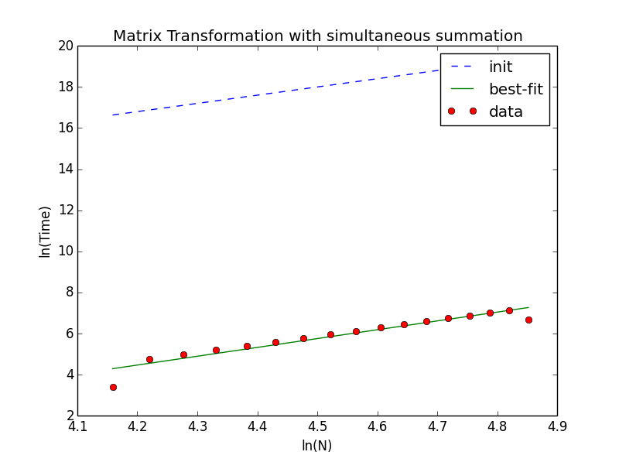

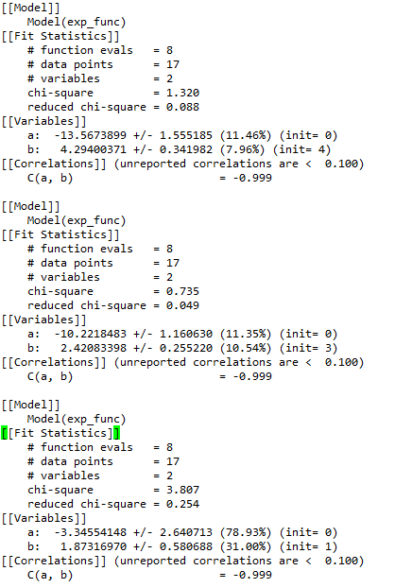

The second graph is also log-log, but of the sequential summation matrix transformation. Fitting this data results in a slope of close to two on the log-log scale, indicating a much weaker dependence of time on matrix size N. While the expectation was a slope of 3, there is a plausible explanation for the difference. Since the function was not fitted with a specified standard error for each data point they were all weighted evenly, thus the outlying first data point would thus cause for the slope to decrease.

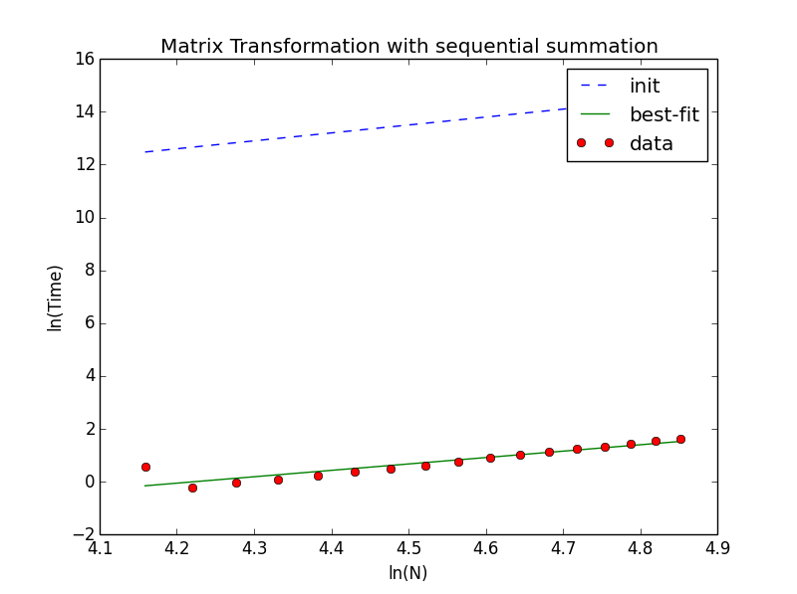



The final plot is a log-log plot of the ratio of time between the simultaneous and sequential matrix transformations. Here the fitting provides a slope of greater than one, so that we have further evidence that the simultaneous transformation has a dependence on N that is one or more power higher than the sequential version. The difference of this result from the expected value is explained by the outlying initial data point in the sequential summation as previously detailed.

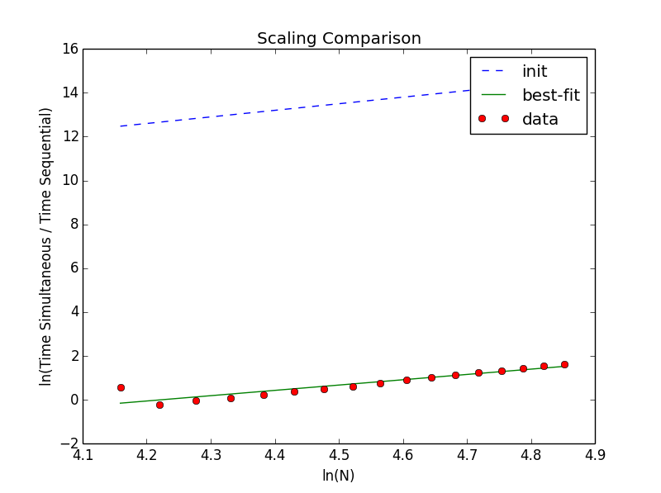



The primary source of error in the measurements is due to the computer running the calculations also being used for other tasks. Peaks in processing power demanded by the other tasks would account for some of the multiplications taking much longer than would otherwise be reasonable. It so happens that this report was first created and drafted when the computation had just begun. However, this theory does not explain the points significantly lower than the fit line in the plot of the simultaneous matrix transformation times.